Service Report

Cafcass

TEST DATE


proudly supporting

Document Control

Title
Filename | TEST
Author
Status | Published
Classification | Restricted

Version Control

Version | Author | Change | Release Date
1.0 | Tom Cassady | Initial Draft

Table of Contents

Support Requests - 13month by Source
Support Requests - Incidents Opened and Resolved Per Month
Incidents - Open and Resolved per Month per Resolver Group

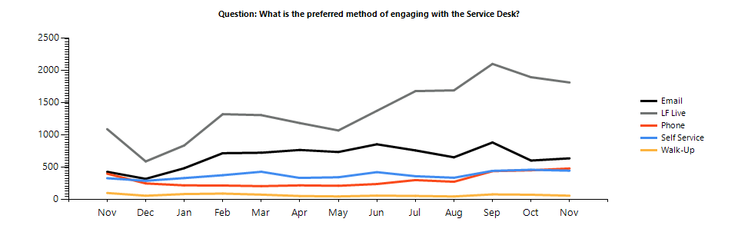
 | Nov | Dec | Jan | Feb | Mar | Apr | May | Jun | Jul | Aug | Sep | Oct | Nov
Email | 423 | 314 | 479 | 712 | 719 | 762 | 730 | 850 | 755 | 648 | 878 | 598 | 632
LF Live | 1085 | 584 | 832 | 1317 | 1302 | 1179 | 1064 | 1369 | 1674 | 1686 | 2096 | 1890 | 1808
Phone | 394 | 243 | 213 | 211 | 201 | 213 | 206 | 234 | 295 | 269 | 433 | 447 | 475
Self Service | 324 | 284 | 326 | 371 | 424 | 328 | 339 | 418 | 355 | 331 | 438 | 455 | 441
Walk-Up | 95 | 52 | 78 | 86 | 69 | 48 | 42 | 54 | 49 | 41 | 73 | 68 | 53
Total | 2321 | 1477 | 1928 | 2697 | 2715 | 2530 | 2381 | 2925 | 3128 | 2975 | 3918 | 3458 | 3409

Analysis

-

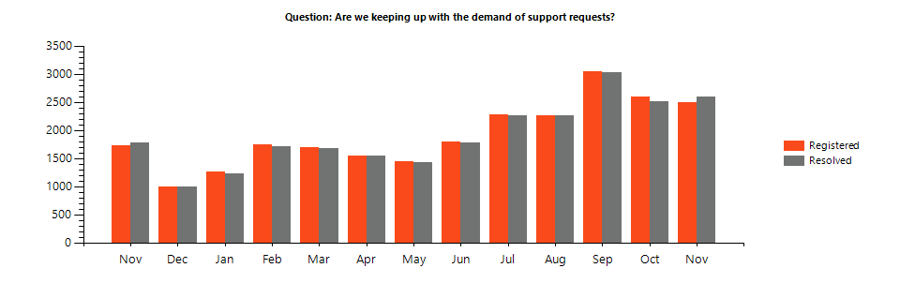
 | Nov | Dec | Jan | Feb | Mar | Apr | May | Jun | Jul | Aug | Sep | Oct | Nov
Registered | 1727 | 987 | 1257 | 1748 | 1689 | 1545 | 1446 | 1797 | 2269 | 2268 | 3045 | 2595 | 2492
Resolved | 1772 | 1001 | 1228 | 1705 | 1679 | 1545 | 1420 | 1780 | 2267 | 2265 | 3031 | 2511 | 2601
Delta | -45 | -14 | 29 | 43 | 10 | 0 | 26 | 17 | 2 | 3 | 14 | 84 | -109

Analysis

-

 |  | Nov | Dec | Jan | Feb | Mar | Apr | May | Jun | Jul | Aug | Sep | Oct | Nov
Littlefish | Open | 166 | 139 | 148 | 228 | 235 | 208 | 205 | 240 | 241 | 262 | 235 | 301 | 264
Littlefish | Open - Older Than 30 days | 166 | 139 | 148 | 228 | 235 | 208 | 205 | 240 | 241 | 262 | 235 | 301 | 56
Littlefish | Monitoring Registered | 487 | 433 | 279 | 151 | 126 | 120 | 119 | 154 | 180 | 292 | 218 | 211 | 395
Littlefish | Monitoring Resolved | 485 | 431 | 278 | 154 | 125 | 122 | 119 | 151 | 183 | 291 | 218 | 211 | 394
Littlefish | Registered (excl. monitoring) | 2292 | 1443 | 1871 | 2635 | 2643 | 2469 | 2324 | 2841 | 3006 | 2868 | 3783 | 3298 | 3216
Littlefish | Resolved (excl. monitoring) | 2307 | 1448 | 1833 | 2531 | 2556 | 2417 | 2271 | 2763 | 2994 | 2817 | 3766 | 3169 | 3230
Littlefish | Delta (excl. monitoring) | -15 | -5 | 38 | 104 | 87 | 52 | 53 | 78 | 12 | 51 | 17 | 129 | -14
Cafcass 3rd Party - Version1 | Open | 3 | 9 | 7 | 12 | 6 | 3 | 9 | 12 | 14 | 15 | 24 | 73 | 18
Cafcass 3rd Party - Version1 | Open - Older Than 30 days | 3 | 9 | 7 | 12 | 6 | 3 | 9 | 12 | 14 | 15 | 24 | 73 | 1
Cafcass 3rd Party - Version1 | Registered (excl. monitoring) | 27 | 28 | 56 | 62 | 65 | 56 | 56 | 80 | 114 | 96 | 105 | 132 | 182
Cafcass 3rd Party - Version1 | Resolved (excl. monitoring) | 30 | 22 | 59 | 57 | 70 | 56 | 51 | 77 | 113 | 97 | 97 | 84 | 243
Cafcass 3rd Party - Version1 | Delta (excl. monitoring) | -3 | 6 | -3 | 5 | -5 | 0 | 5 | 3 | 1 | -1 | 8 | 48 | -61
Cyber Security | Open | 0 | 0 | 1 | 0 | 0 | 0 | 0 | 1 | 2 | 1 | 3 | 1 | 0
Cyber Security | Open - Older Than 30 days | 0 | 0 | 1 | 0 | 0 | 0 | 0 | 1 | 2 | 1 | 3 | 1 | 0
Cyber Security | Monitoring Registered | 0 | 0 | 4 | 2 | 1 | 0 | 0 | 1 | 21 | 165 | 181 | 182 | 108
Cyber Security | Monitoring Resolved | 0 | 0 | 4 | 2 | 0 | 1 | 0 | 1 | 16 | 165 | 186 | 181 | 109
Cyber Security | Registered (excl. monitoring) | 0 | 5 | 1 | 0 | 7 | 3 | 1 | 3 | 8 | 11 | 30 | 28 | 9
Cyber Security | Resolved (excl. monitoring) | 0 | 5 | 0 | 1 | 7 | 3 | 1 | 2 | 7 | 13 | 28 | 33 | 9
Cyber Security | Delta (excl. monitoring) | 0 | 0 | 1 | -1 | 0 | 0 | 0 | 1 | 1 | -2 | 2 | -5 | 0
Cafcass IT | Open | 1 | 1 | 1 | 0 | 0 | 0 | 0 | 0 | 0 | 0 | 0 | 0 | 0
Cafcass IT | Open - Older Than 30 days | 1 | 1 | 1 | 0 | 0 | 0 | 0 | 0 | 0 | 0 | 0 | 0 | 0
Cafcass IT | Registered (excl. monitoring) | 2 | 1 | 0 | 0 | 0 | 0 | 0 | 0 | 0 | 0 | 0 | 0 | 2
Cafcass IT | Resolved (excl. monitoring) | 1 | 1 | 0 | 1 | 0 | 0 | 0 | 0 | 0 | 0 | 0 | 0 | 1
Cafcass IT | Delta (excl. monitoring) | 1 | 0 | 0 | -1 | 0 | 0 | 0 | 0 | 0 | 0 | 0 | 0 | 1
Cafcass 3rd Party - APM Geode | Open | 0 | 0 | 0 | 0 | 0 | 2 | 0 | 0 | 0 | 0 | 0 | 0 | 0
Cafcass 3rd Party - APM Geode | Open - Older Than 30 days | 0 | 0 | 0 | 0 | 0 | 2 | 0 | 0 | 0 | 0 | 0 | 0 | 0
Cafcass 3rd Party - APM Geode | Registered (excl. monitoring) | 0 | 0 | 0 | 0 | 0 | 2 | 0 | 0 | 0 | 0 | 0 | 0 | 0
Cafcass 3rd Party - APM Geode | Resolved (excl. monitoring) | 0 | 0 | 0 | 0 | 0 | 0 | 2 | 0 | 0 | 0 | 0 | 0 | 0
Cafcass 3rd Party - APM Geode | Delta (excl. monitoring) | 0 | 0 | 0 | 0 | 0 | 2 | -2 | 0 | 0 | 0 | 0 | 0 | 0
 | Registered (excl. monitoring) | 0 | 0 | 0 | 0 | 0 | 0 | 0 | 1 | 0 | 0 | 0 | 0 | 0
 | Resolved (excl. monitoring) | 0 | 0 | 0 | 0 | 0 | 0 | 0 | 1 | 0 | 0 | 0 | 0 | 0
 | Delta (excl. monitoring) | 0 | 0 | 0 | 0 | 0 | 0 | 0 | 0 | 0 | 0 | 0 | 0 | 0

